
An OASIS White Paper
Open by Design
The Advantages of the OpenDocument Format (ODF)
By the OASIS ODF Adoption TC
For OASIS

OASIS (Organization for the Advancement of Structured Information Standards) is a not-for-profit, international consortium that drives the development, convergence, and adoption of e-business standards. Members themselves set the OASIS technical agenda, using a lightweight, open process expressly designed to promote industry consensus and unite disparate efforts. The consortium produces open standards for Web services, security, e-business, and standardization efforts in the public sector and for application-specific markets. OASIS was founded in 1993. More information can be found on the OASIS website at http://www.oasis-open.org.
The purpose of the OASIS OpenDocument Format Adoption Committee is to create awareness and demand for a new class of applications and solutions designed specifically to support and leverage OpenDocument XML (commonly referred to as the OpenDocument Format or ODF). The Adoption Committee dedicates its energy and resources to creating wide-scale understanding of the benefits of OpenDocument Format support within organizations and governmental bodies through education and promotion. The Adoption Committee aligns and supports the activities of the OASIS OpenDocument Technical Committee by providing market-based requirements. These requirements help guide future development of the OpenDocument specification by the OASIS OpenDocument Technical Committee.

Table of Contents

Why an Open File Format Matters 4
Approved by OASIS and ISO: An Overview of ODF 5
A Long Tradition of Openness: The History of ODF 7
Open by Design: The Benefits of ODF 10
Learning more about ODF: Resources for Users and Developers 14

Why an Open File Format Matters
In a world where paper documents are increasingly replaced by electronic records, ensuring that long term access and usability of these records is critical. This is especially the case for legal contracts and government documents, which stay valid and relevant over decades, or even centuries. But it is no less the case for personal documents.
Just as paper and pens have been available from multiple vendors, and not just one single source, document file formats and the applications creating these file formats need to be supported by and available from multiple vendors. This guarantees long-term access to data even if companies cease to operate, change their strategies, or dramatically raise their prices. In effect, with choice the user retains control over and ownership of the documents she authors; she is no longer dependent on a single vendor to read and edit her work.
Open standards that are equally accessible and do not favor one particular vendor can help maintain a diverse ecosystem of vendors. This also fosters competitive pricing, thus creating the conditions for the best use of money from investors to tax payers.
Open standards lower the barrier to entry, allowing new companies to join the ecosystem. For example, the SQL standard for relational databases allowed the emergence of various implementations, including free and open source and very specialized high-end database management systems. As long as only standard SQL features are used, data stored in database management systems can be exchanged without much effort. A user may choose a SQL implementation that includes unique, vendor-specific elements in addition to the basic, but that is her choice. Thus, vendor lock-in becomes a choice, not an unfortunate necessity.
In the case of public documents that governments provide to their nation's residents, it is also important that no resident be excluded from data access. For example, nobody should be forced to buy software from one particular vendor or for one particular operating system platform. Public data should be accessible to residents independent of their income and their physical abilities.

Approved by OASIS and ISO: An Overview of ODF
The OpenDocument Format (ODF) is an open, XML-based document file format for office applications that create and edit documents containing text, spreadsheets, charts, and graphical elements. The file format makes transformations to other formats simple by leveraging and reusing existing standards wherever possible.
ODF is defined via an open and transparent process at OASIS (Organization for the Advancement of Structured Information Standards) and has been approved unanimously by the Joint Technical Committee 1 (JTC1) of the International Organization for Standardization (ISO) and the International Electrotechnical Commission (IEC) as an International Standard (IS) in May 2006. It is available for implementation and use free of any licensing, royalty payments, or other restrictions.
From a technical point of view, ODF is a ZIP archive that contains a collection of XML files that describe the document's content and presentation. Binary files are only used for such things as embedded images. The use of XML makes accessing the document content simple, because content can be opened and changed with simple text editors, if necessary. In contrast, the previously used proprietary binary-only file formats were cryptic and difficult to process.
The ZIP compression guarantees relatively small file sizes, which reduce file storage and transmission bandwidth requirements; this make s it easier to exchange files, regardless of bandwidth. (ODF was the first broadly used document file format that used a ZIP package containing different XML files.) ODF uses the same set of XML files for different application types. In addition, definitions for elements like tables are consistent across application types.

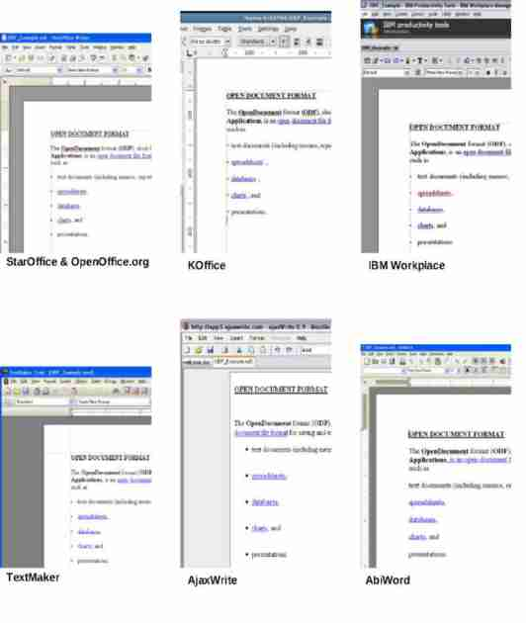Picture 1: Different ODF Implementations

A Long Tradition of Openness: The History of ODF
The OpenDocument Format has a long tradition of openness. The first work on the file format started as early as 1999. Right from the beginning, ODF was designed as an open and implementation neutral file format.
The open specification process started in 2000 with the foundation of the OpenOffice.org open-source project and the community efforts within its XML development project. An even higher level of openness was established in 2002 with the creation of the OASIS Open Office Technical Committee (TC).
During the last seven years, an increasing number of organizations and companies have joined the ODF specification process. In addition, a growing number of applications implement the OpenDocument file format. Table 1 provides an overview of the history of the OpenDocument Format.
Date / Time Frame | Event / Milestone
1999 | The Development of an XML default file format begins at StarDivision. Limitations of the old binary format and a need for Unicode support trigger the change. The goal is to create an open, interoperable file format that can be used and implemented by other vendors as well.
August 1999 | Sun Microsystems, Inc. acquires StarDivision.
13 October 2000 | Sun Microsystems, Inc., releases the source code to StarOffice under open licenses to the recently founded (July 2000) OpenOffice.org project.
13 October 2000 | The XML community project is set up in OpenOffice.org with the goal of defining the specification of the OpenOffice.org XML file format as an open community effort.
2002 | Definitions for CJK (Chinese, Japanese, Korean) and complex text layout languages are added to the OpenOffice.org XML file format specification.
2002 | Collaboration with the KOffice project begins.
16 December 2002 | The OASIS Open Office Technical Committee (TC) has its first conference call.
May 2002 | OpenOffice.org 1.0 and StarOffice 6 are released, both using the OpenOffice.org XML file format as the default file format.
August 2003 | KOffice decides to use ODF as its default file format.
2003 / 2004 | The original OpenOffice.org XML file format specification is modified to reflect recent developments in the XML and office application area, e.g.:  * Introduction of XML namespaces that conform to the OASIS naming rules  * Switching from XML DTDs to Relax-NG as the schema language  * Improvements of the schema to better support the validation of documents  * Adaptation of the schema to new versions of standards  * Adaptations for additional office applications (KOffice)  * Adaptations for new office application versions (OpenOffice.org 2.0)  * Removal of inconsistencies in the specification  * Error corrections
December 2004 | A second committee draft is approved, and the title of this draft is changed from “OASIS Open Office Specification” to “OASIS Open Document Format for Office Applications (OpenDocument)”
January 2005 | The TC is renamed to OASIS Open Document Format for Office Applications (OpenDocument) TC.
February 2005 | The third file format specification draft including public review feedback is approved as a committee draft.
May 2005 | The OpenDocument Format (ODF) is approved as an OASIS standard.
September 2005 | Sun Microsystems releases StarOffice 8 with ODF support.
September 2005 | ODF is submitted to the International Organization for Standardization (ISO).
September 2005 | INdT (research group belonging to Nokia) contributes ODF filters for Abiword and Gnumeric.
October 2005 | OpenOffice.org 2.0 is released with ODF support.
October 2005 | Sun issues a patent covenant statement:  “Sun's public non-assertion declaration may be summarized unofficially as an irrevocable covenant not to enforce any of its enforceable U.S. or foreign patents against any implementation of the OASIS OpenDocument specification”  (http://xml.coverpages.org/ni2005-10-04-a.html)
December 2005 | Softmaker releases Textmaker 2006 with ODF support.
January 2006 | IBM releases IBM Workplace with ODF support.
March 2006 | The ODF Alliance is founded with 35 initial members in order to promote ODF in the public sector.
March 2006 | The OASIS ODF Adoption TC is founded with the aim of educating the marketplace of the value of ODF.
April 2006 | KOffice 1.5, which uses ODF as the default file format, is released.
May 2006 | ISO approves ODF as ISO/IEC 26300.
June 2006 | The ODF Alliance already has more than 200 members including companies, organizations, and municipalities such as BBC, Corel, EDS, EMC, IBM, Novell, Red Hat, Oracle, Software AG, Sun Microsystems, and the City of Vienna.
September 2006 | ODF 1.0 Second Edition completed bringing in editorial changes identified in the ISO review process..
October 2006 | ODF 1.1 approved as Committee Specification; to be submitted for an OASIS Standard vote in January 2007 Continuing development of formula, accessibility and metadata deliverables planned for publication in 2007 as ODF 1.2. ODF Alliance membership surges past 300 members from over 40 countries .
Table 1: The History of ODF

Open by Design: The Benefits of ODF
The OpenDocument Format was designed to be vendor neutral and implementation agnostic. It was designed to be used by as many applications as possible. In order to simplify transformations and to maximize interoperability, the format reuses established standards such as XHTML, SVG, XSL, SMIL, XLink, XForms, MathML, and Dublin Core. ODF files of different application types (e.g., the word processor, spreadsheet) include the same set of XML files within the ZIP packages. Picture 2 shows a simple ODF text document and the contents of the corresponding ZIP package.

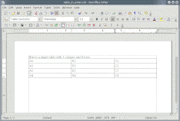
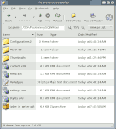
Picture 2: An ODF text document unzipped
unzip
Picture 3 shows a simple ODF spreadsheet document and its ZIP archive contents. Both the text document and the spreadsheet document have the same structure, e.g., both contain a content.xml, a styles.xml, and a meta.xml file.

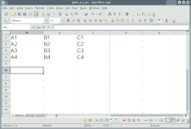
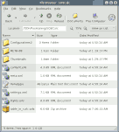
Picture 3: An ODF spreadsheet document unzipped
unzip

Pictures 4 and 5 illustrate that tables within text documents are defined by the same XML elements as tables within spreadsheet documents. Using the same set of XML files within ODF documents as well as defining similar document elements across application types with the same XML elements makes transforming and processing ODF documents simple.
Picture 4 shows the content.xml file with a table definition of a text document.

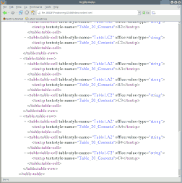
Picture 4: content.xml file of a text document viewed in the Mozilla Firefox browser
Picture 5 shows the table definition of a spreadsheet document. The same XML elements are used to define tables in spreadsheet documents as in text documents.

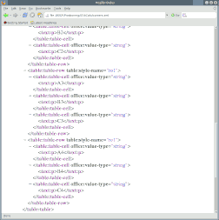
Picture 5: content.xml file of a spreadsheet document viewed in the Mozilla Firefox browser

Table 2 highlights the key features and benefits of the OpenDocument Format.
Feature | Benefit
OASIS standard | Open, transparent specification process with multi-vendor participation
Approved by ISO as ISO/IEC 26300 | Well known and broadly accepted standard
ISO standard Relax-NG schema types (ISO/IEC 19757-2:2003) | Well known and broadly accepted standard
Supported by multiple applications | Choice between free, open-source and commercial implementations including OpenOffice.org, StarOffice, KOffice, IBM Workplace, Textmaker, Abiword/Gnumeric, Google Docs & Spreadsheet, and AjaxWrite.
Broad industry support | ODF guarantees long-term viability. The OASIS ODF TC, the OASIS ODF Adoption TC, and the ODF Alliance include members from Adobe, BBC, Bristol City Council, Bull, Corel, EDS, EMC, GNOME, IBM, Intel, KDE, MySQL AB, Novell, Oracle, Red Hat, Software AG, Sun Microsystems, and the City of Vienna. As of December 2006, the ODF Alliance already has more than 350 members.
Shipping products since September 2005 | ODF files can already be created and used today. The first products with ODF support started shipping in September 2005.
Free open source “reference” implementations | ODF is supported by multiple free, open-source office applications including OpenOffice.org, KOffice and Abiword/Gnumeric. OpenOffice.org, for example, is developed by a large community including vendors like Sun Microsystems, Novell, Intel, and Red Hat. Because the source code is available, anyone can add support for additional platforms.
ODF implementations available for all major desktop platforms | Applications with ODF support are available for Microsoft Windows, Linux, the Solaris OS, Apple Mac OS X, and FreeBSD.
Open standard W3C XForms technology is used for forms | The forms concept integrated into ODF is based on the W3C XForms standard which is supported by multiple applications and vendors.
Reuse of existing standards where possible | In order to make interoperability as simple as possible, ODF reuses established standards such as XHTML, SVG, XSL, SMIL, XLink, XForms, MathML, and Dublin Core.
Well established | The first work for the ODF file format started as early as 1999 (see the ODF history in Table 1).
Table 2: Benefits of ODF

Learning more about ODF: Resources for Users and Developers

- OASIS Open Document Format TC Homepage
http://www.oasis-open.org/committees/tc_home.php?wg_abbrev=office
- OASIS ODF Adoption TC Homepage
http://www.oasis-open.org/committees/tc_home.php?wg_abbrev=odf-adoption
- ODF Information Web Site
http://www.opendocument.xml.org
- ODF Alliance Homepage
http://www.odfalliance.org/about.php
- ODF Wikipedia Page
http://en.wikipedia.org/wiki/OpenDocument
- Online Book: OASIS OpenDocument Essentials
http://books.evc-cit.info/
- ODF Perl Module
http://search.cpan.org/dist/OpenOffice-OODoc/

